1. Web Lazy Ballot

CouchDB : NoSQL injection

1. Crypto Initiatlization

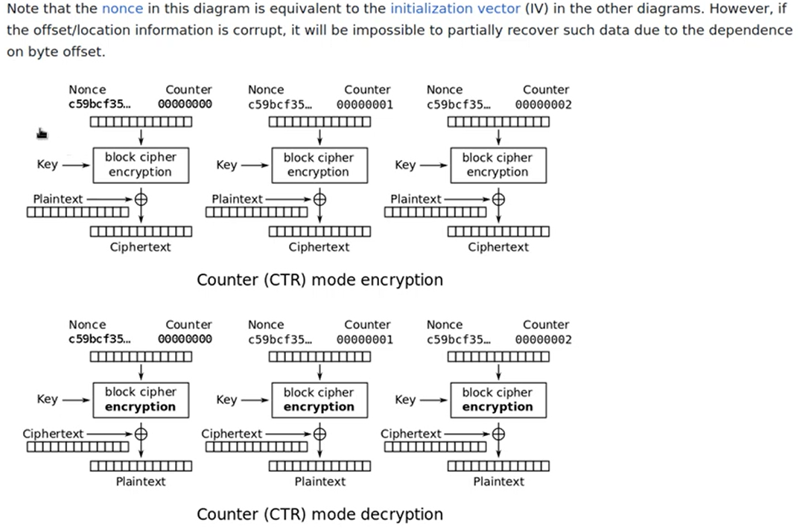

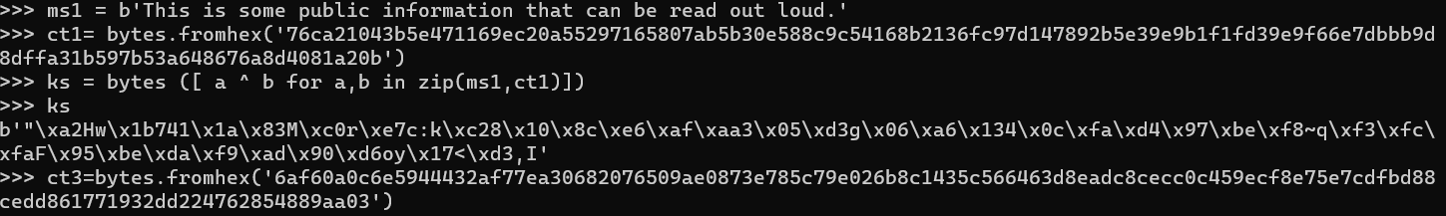

ms1 = b'This is some public information that can be read out loud.'

>>> ct1= bytes.fromhex('76ca21043b5e471169ec20a55297165807ab5b30e588c9c54168b2136fc97d147892b5e39e9b1f1fd39e9f66e7dbbb9d8dffa31b597b53a648676a8d4081a20b')

>>> ks = bytes ([ a ^ b for a,b in zip(ms1,ct1)])

>>> ks

b'"\xa2Hw\x1b741\x1a\x83M\xc0r\xe7c:k\xc28\x10\x8c\xe6\xaf\xaa3\x05\xd3g\x06\xa6\x134\x0c\xfa\xd4\x97\xbe\xf8~q\xf3\xfc\xfaF\x95\xbe\xda\xf9\xad\x90\xd6oy\x17<\xd3,I'

>>> ct3=bytes.fromhex('6af60a0c6e5944432af77ea30682076509ae0873e785c79e026b8c1435c566463d8eadc8cecc0c459ecf8e75e7cdfbd88cedd861771932dd224762854889aa03')

>>> flag = bytes ([ a ^ b for a,b in zip(ct3,ks)])

>>> flag

b'HTB{unpr0t3cted_bl0ckch41n_s3cur1ty_p4r4m3t3rs!!!}\x0e\x0e\x0e\x0e\x0e\x0e\x0e\x0e'